**Tools used to build** website

* PHP
* JavaScript
* MySQL
* HTML
* CSS
* Xampp
* Swiper.js
* Trello
* GitHub

**How the tools are integrated**

**CSS** was added to **HTML** externally by using the <link> element to link HTML to an external CSS file in the <head> section

**Trello**

It was used to create list of tasks that had to be done by each member of the group after each task was done it had to be uploaded on ***GitHub.***

**GitHub**

The group leader created a repository and invited group members to join so that they can be able to contribute to the project. Each contributor in the GitHub project created a repository that contained files with code or images and uploaded them. GitHub was used to store files that contained ***HTML, CSS, JavaScript, PHP, MySQL*** codesthat were uploaded by the contributors and to track the project.

**Narrative**

It’s a website designed by students for students to pursue IT related fields that can assist them to improve their knowledge in IT. The platform will offer resources such as textbooks, GitHub repositories, links for educational API’s, bursaries and external assistance page and different tutors.

The users will be urged to sign up with their Username, Email and create a password if the user already has an account they must sign in with their credentials. After logging in the user will be directed to the home page where they will see different tabs such as the textbook, resources, tutors and the contact tab.

The ***Home Page*** will have a **Dive In** button when the user clicks it will direct to the ***Textbook Page*.**

The ***Textbook Page*** will contain different books related to IT and science such as Python, JavaScript, Web development, Cybersecurity, Software Engineering, Data Science.

The ***Student Resources page*** will contain the student financing bursaries, GitHub repositories and developer environment setup guide.

The website will have a ***Contact Us Page*** where the user will enter their credentials and select the course, they need help with from the tutors.

**Mockups**

**User opens website**

**IF it’s the user first time using the website they’ll be asked to signup**

**Sign Up Page Login Page**

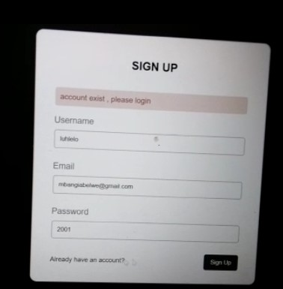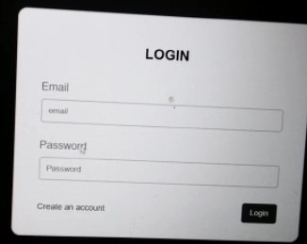

**If the credentials are correct the user will be directed to the Home page**

**Home Page About Page**

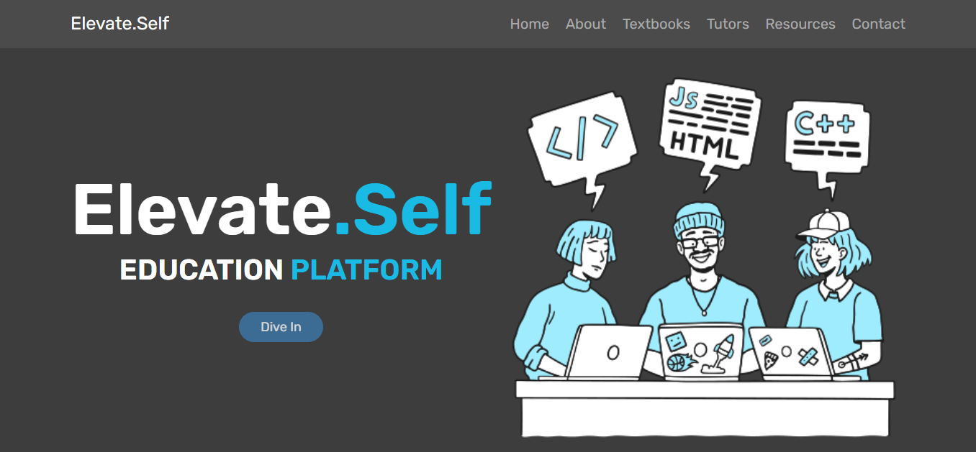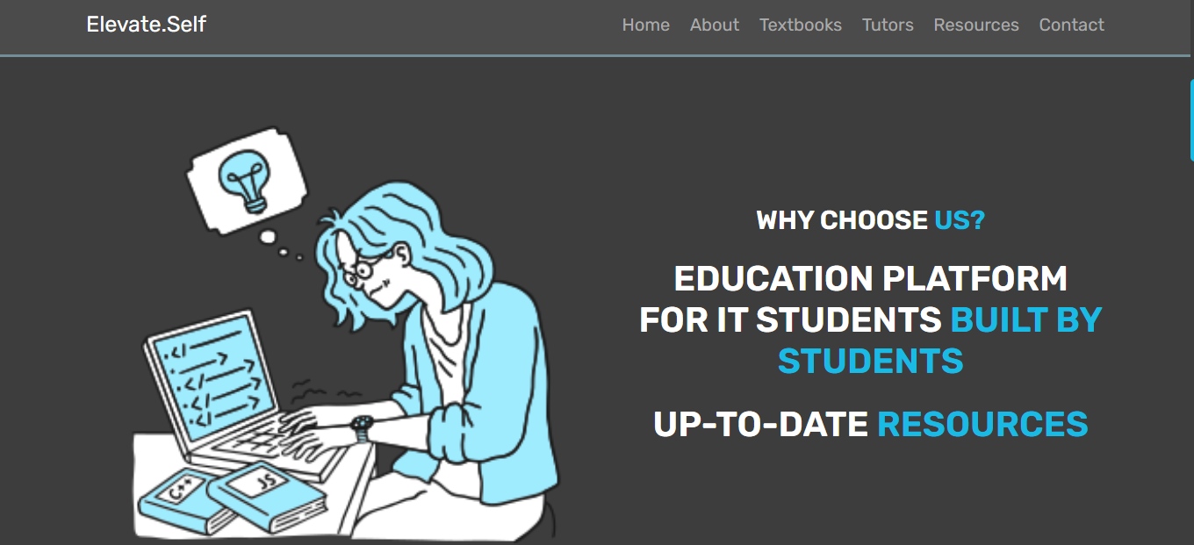

**Textbook Page**

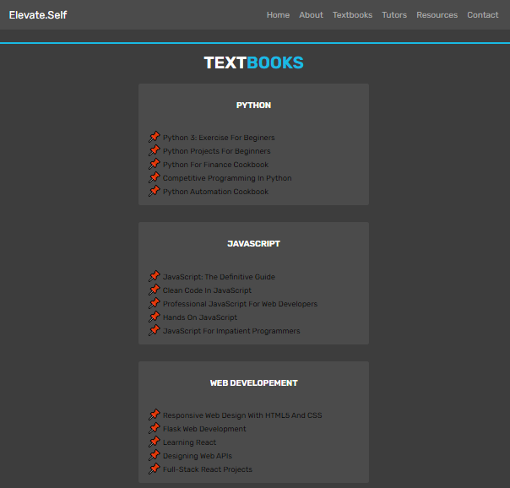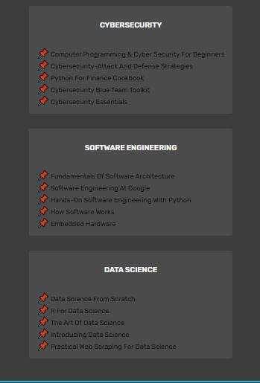

**Tutors Page**

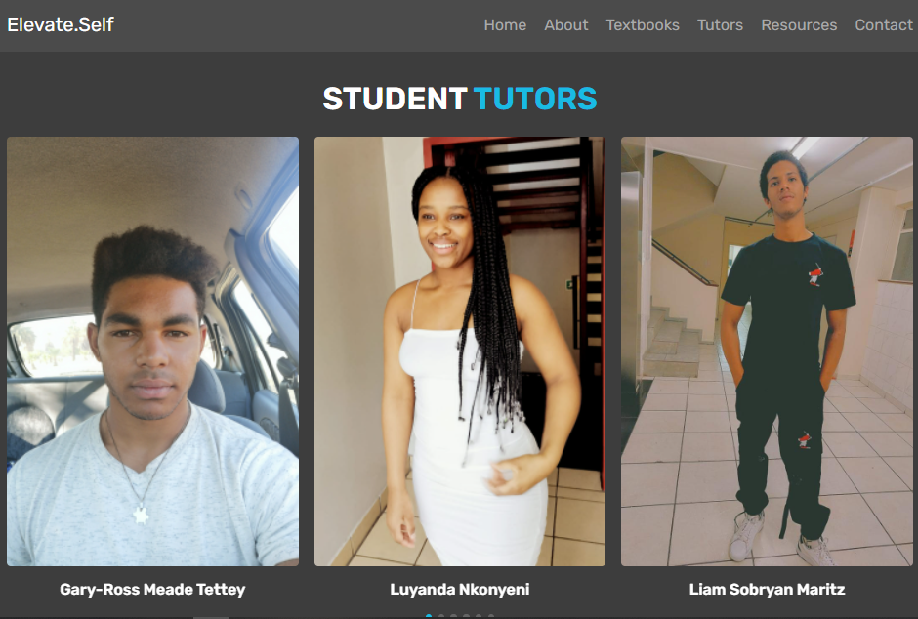

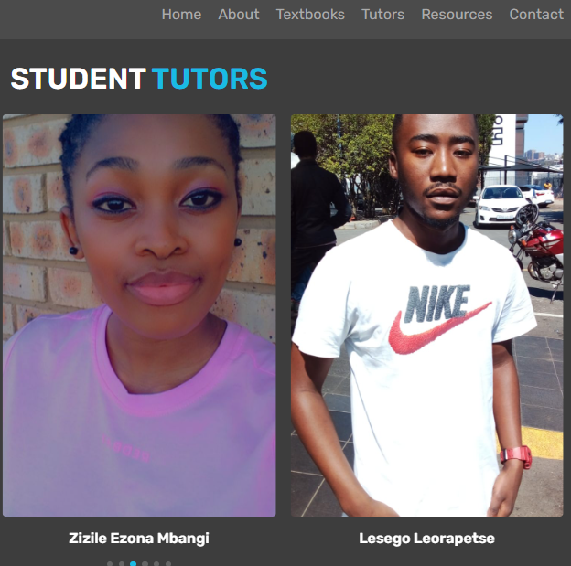

**Student’s Resources Page**

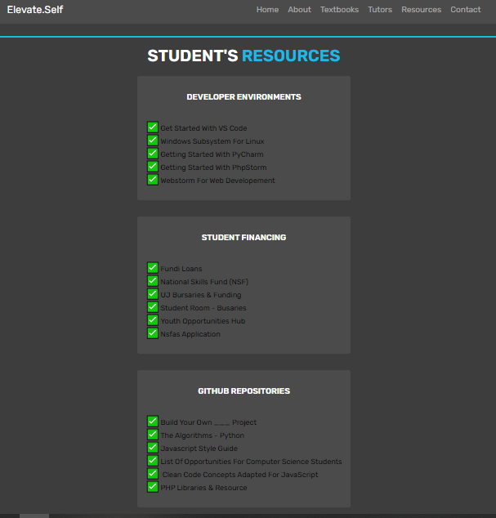

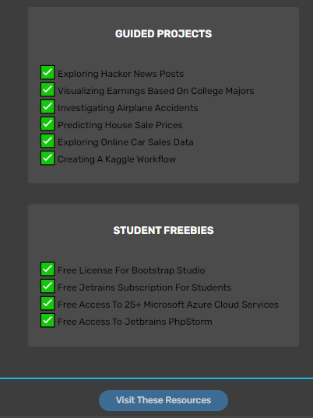

**Contact US Page**

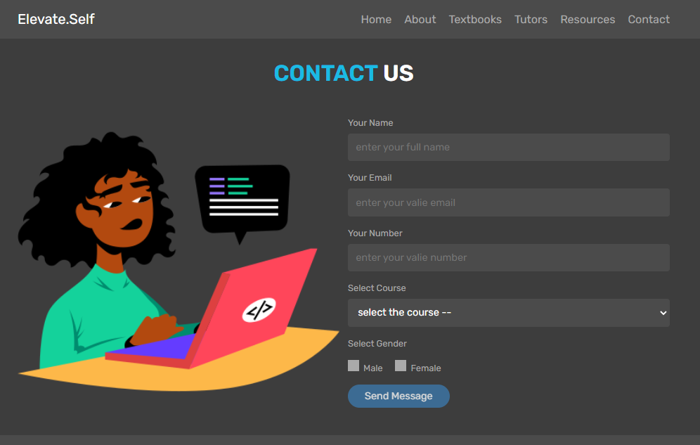

**Page to Page**

**Home Page**

The user will have a dive in button when clicked it will direct to the textbook page.

**Textbook Page**

The page will provide the user with different books.

**Tutors Page**

The page allows the user to pick the tutor they want to help them with things related to the website.

**Resources Page**

It provides the user with different student financing bursaries, GitHub repositories and developer environment guides.

**Contact Us Page**

The user has to enter their credentials and select the course they have a query about so that they can get help from one of the tutors.